
15 Church Lane Wicklewood Wymondham Norfolk NR18 9QH
01953 609141
e-mail: info@garlictheatre.org.uk
www.garlictheatre.org.uk

Hickory Dickory Dock
Technical sheet and LIGHTING CUES
for Theatres and Art Centres

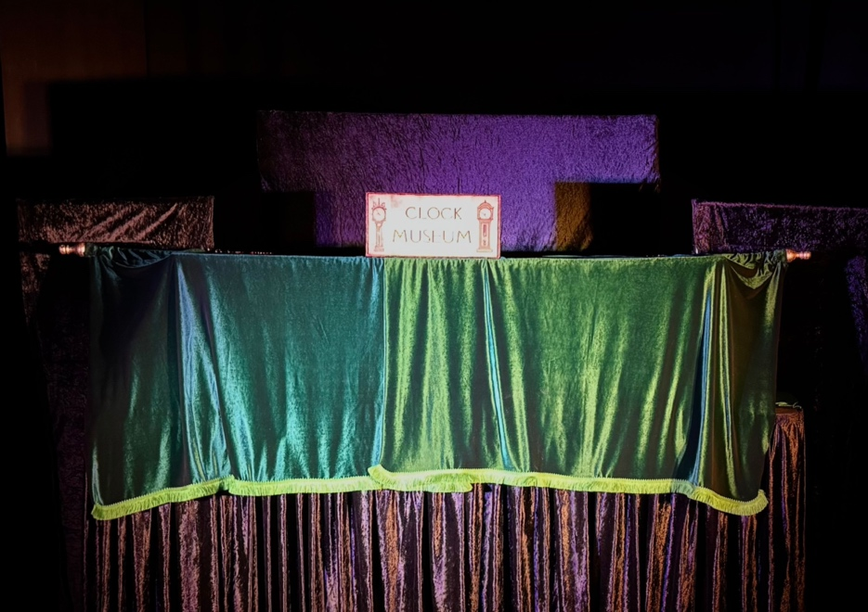

Playing Area 4 metres width by 4 metres depth 2.6 metres high

Sound
Garlic Theatre provide 1 sound track for the show to be cued by the technician and using the theatre’s sound system. If this is not possible please let Garlic Theatre know and Garlic Theatre can bring speakers and an ipad and operate the sound herself. We can send the soundtrack in advance on request.

Timings
The set up time is 2 hours, after bringing the set and puppets into the space.
The performance is 45 minutes with time at the end to show puppets and to answer any questions from the public
The get out time is 1 hour

Lighting States
- Preset mix of red and blue
- General state
- 2 lights focussed on the upper and lower parts of the puppet booth
- 2 lights focussed on top of the 2 black side panels
- Red state
- Blue light from above to help performers find things inside the booth

PRE SHOW MUSIC PLAYING FOR AUDIENCE TO COME INTO THE SPACE

Cue 1
Preset mix of red and blue

Cue 2 Fade to black out

MUSIC CUE TRACK 1

Cue 3 Mouse comes up
One light focussed on the upper part of the puppet booth for the mouse.

Cue 4 Iklooshar comes out
Bring up general state to light the front of the booth including the 2 lights focussed on the upper and lower parts of the puppet booth and the 2 lights on the side panels

Cue 5 Iklooshar and Mark take away the green curtains at the front to reveal red curtains
Lower the general state keeping the 2 lights focussed on the upper and lower parts of the puppet booth and the 2 lights on the side panels

Cue 6 Iklooshar and Mark come out as delivery drivers
Bring up the general state and the audience lights

Cue 7 Red curtains open again
Take away the audience lights. Lower the general state and keep the 2 lights focussed on the upper and lower parts of the puppet booth and the lights on the side panel

Cue 8 Mrs Hickory gets rid of the pig, talks on the phone to the Repair man and looks for the mouse. Shouts Dickory and Dickory comes up with a HAMMER and the mouse and cat chase in the booth and out into the audience
Red State

Cue 9 Mrs Hickory catches mouse with a net in the booth
Fade out red state

Cue 10 Green curtains on the booth again by Iklooshar and Mark
Bring up general state to light the front of the booth including the 2 lights focussed on the upper and lower parts of the puppet booth and the lights on the side panels

Cue 11 Song with audience Hickory Dickory Dock
Add some audience lights

Cue 12 Big mice sing Hickory Dickory Dock as finale and disappear
Blackout

Cue 13 Bow and meet and greet the puppets
Bring up general state and audience lights

PRE SHOW MUSIC PLAYING FOR AUDIENCE TO MEET AND GREET THE PUPPETS

