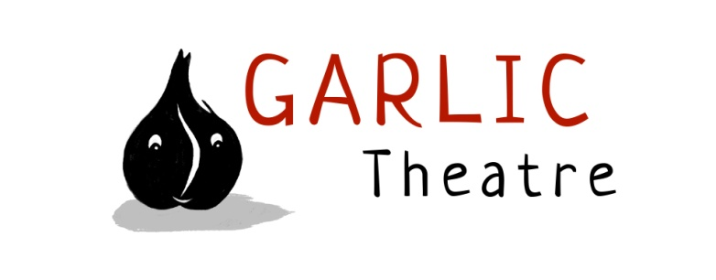
15 Church Lane Wicklewood Wymondham Norfolk NR18 9QH
01953 609141
e-mail: info@garlictheatre.org.uk
www.garlictheatre.org.uk

The Forgotten Tailor
Work in Progress by Garlic Theatre
Copy

The Forgotten Tailor is work in progress. Mark shares a personal quest to find more about the life of his father Fred Pitman, whose family had a tailors shop in Lahore in the 1930ies. Through the use of storytelling and shadows we explore the way you can try and piece together the threads of a person's life through memories and objects
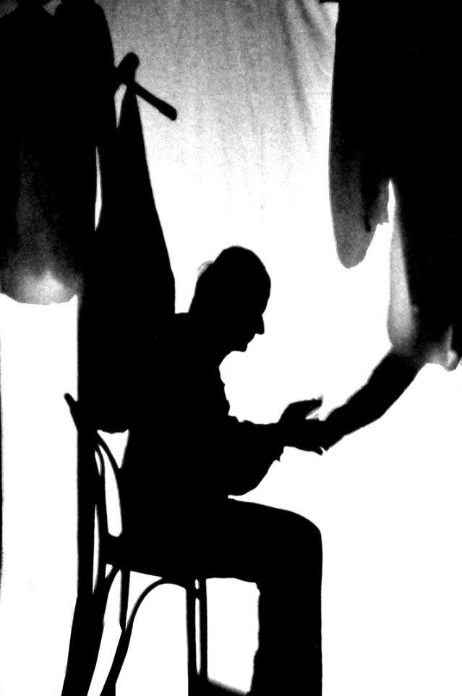

Photograph by Ray Martin
Performer: Mark Pitman
Director: Steve Tiplady Indefinite articles
Mentor: Steffi Muller Hoipolloi
Music by Iklooshar Malara

