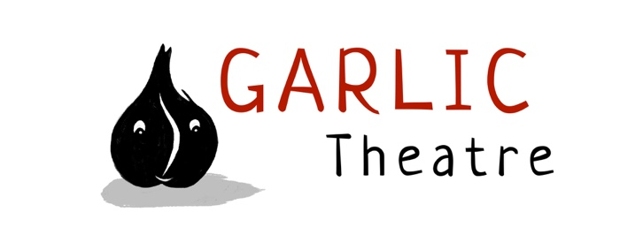

15 Church Lane Wicklewood Wymondham Norfolk NR18 9QH
01953 609141
e-mail: info@garlictheatre.org.uk
www.garlictheatre.org.uk

The bag that went BOO!

Technical sheet and LIGHTING CUES for theatres and art centres

Playing Area 4 metres width by 4 metres depth 2.6 metres high

Sound
Garlic Theatre provide their own sound to be operated by the Performer or if possible by the technician using the sound system in the theatre. There is 1 cue.

Timings
The get in is 2 hours with a reasonable access to the performance space.
The performance is 45 minutes with a 10 minutes optional puppet demo at the end of the show respecting covid guidelines.
The get out time is 1 hour.

Requirements
Please provide a 13 amp socket at the back of the stage

Lighting States
- Preset (blue wash suggested)
- Warm general state focussed on the playing area with some red in it.
- 1 focussed spot on the table
- Blue wash for underwater and arctic scenes

Lighting Cues

Audience coming in

Preset
Blackout

TRACK 1 45 minutes
CUE 1
15 sec fade up warm state
Big brown bag appears SR

CUE 2
Mark driving the car screeches to a halt and sound of seagulls.
Add blue wash at 50%
CUE 3
Mark swimming
Take out general state and bring blue wash up to 100%

CUE 4
Mark rescues bag and comes back to the beach
Take out the blue wash and bring up general state at 100%

CUE 5
Mark lifts a big white sheet to cover the main table as snow.
General wash at 50% and blue wash at 100%

CUE 6
Mark removes the white sheet of snow
General wash at 100% and take out the blue wash.

CUE 7
End of show
Mark leaves the stage waving goodbye and the big yellow balloon disappears behind the backdrop.
Slow fade to black

CUE 8
Lights up for curtain call

